SIMATS ENGINEERING

ASSESSMENT TOOL 1
Analytical Problem Solving
Course: Cloud Computing and Big Data Analytics | Course Code: CSA15
Course Outcome CO2: Analyze virtualization architectures to identify performance and security issues in cloud computing environments.

Student Name | M. Akhil kumar
Register Number | 192572060

Code of Conduct
I certify that this submission is my original work and that I have adhered to the guidelines specified for this assessment. I understand that any violation of academic integrity rules will result in disciplinary action.

Question 1: Compare Type-1 and Type-2 Hypervisors

Introduction
A hypervisor, also called a virtual machine monitor (VMM), creates and manages virtual machines (VMs) by sharing a physical server’s CPU, memory, storage and network resources. Type-1 and Type-2 hypervisors differ mainly in where the virtualization layer runs.
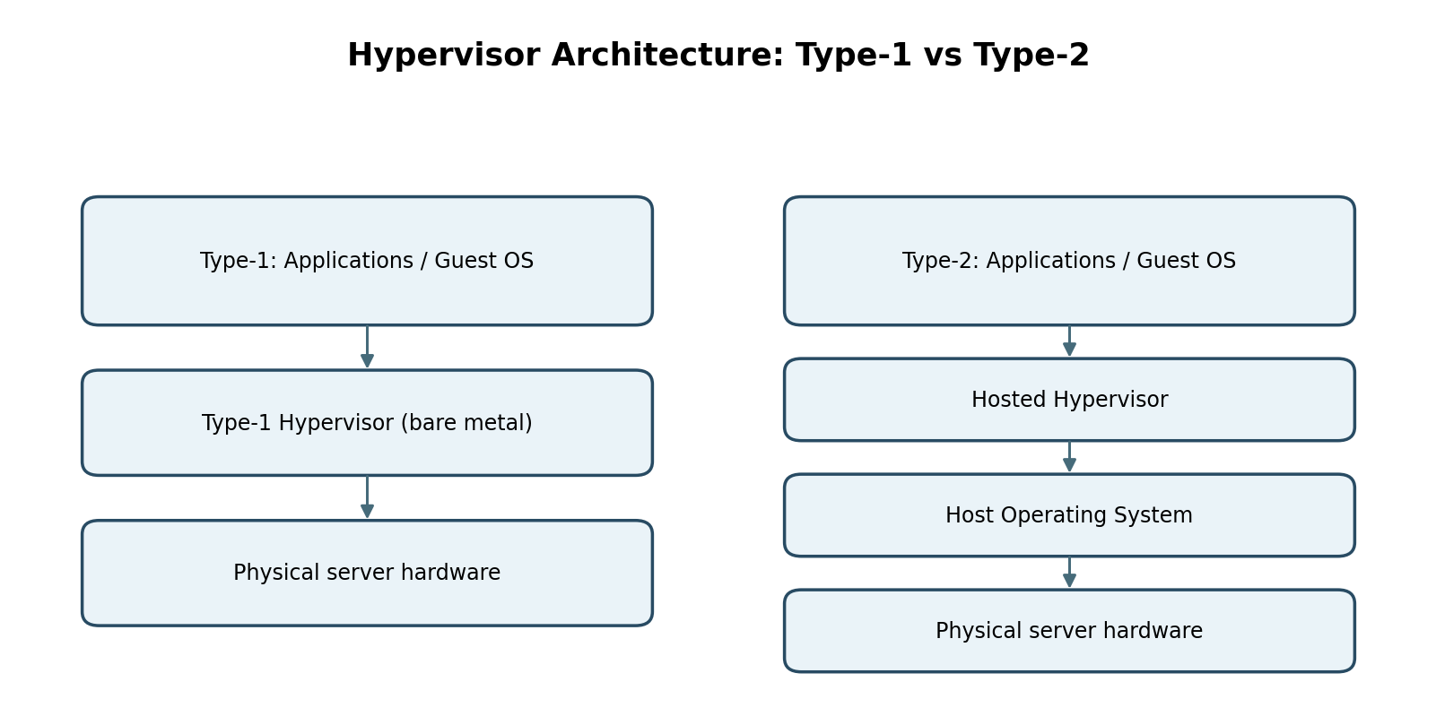

Type-1 Hypervisor (Bare-Metal)
A Type-1 hypervisor runs directly on the physical hardware. Guest operating systems run above the hypervisor, without a general-purpose host operating system between them. Examples include VMware ESXi, Microsoft Hyper-V (hypervisor architecture) and Xen.
- Performance: Usually lower overhead and more predictable resource scheduling, making it suitable for demanding workloads.
- Security: A smaller host software stack can reduce exposure, although the hypervisor itself remains a critical attack surface and must be patched and hardened.
- Manageability: Designed for centralized administration, VM templates, clustering, live migration, monitoring and policy-based resource allocation.

Type-2 Hypervisor (Hosted)
A Type-2 hypervisor runs as an application on top of a host operating system. Examples include Oracle VirtualBox and VMware Workstation.
- Performance: Adds host-OS and application-layer overhead; performance may be less predictable under heavy contention.
- Security: Depends on the security of both the host operating system and the hypervisor application, increasing the components that must be secured.
- Manageability: Convenient for desktops, labs, development and testing, but generally less suited to large production fleets than a purpose-built server virtualization platform.

Comparison and Recommendation
Criterion | Type-1 | Type-2
Performance | Direct hardware access; typically lower overhead | Runs through host OS; more overhead
Security | Fewer layers between hypervisor and hardware; strong hardening still required | Host OS adds another layer and attack surface
Manageability | Enterprise tools, clustering and live migration are common | Simple desktop-oriented management
Best fit | Production cloud datacenters and mission-critical services | Development, training and desktop testing

Question 2: Isolating Finance, Healthcare and Student Workloads

How Virtualization Provides Isolation
The provider can place each workload in separate VMs or strongly isolated containers, while the hypervisor controls access to physical CPU, memory and devices. Separate virtual networks, firewall rules, storage permissions and encryption keys add layers of separation. Sensitive finance and healthcare systems should use stricter access policies and may require dedicated hosts or confidential-computing controls depending on regulatory and threat requirements.
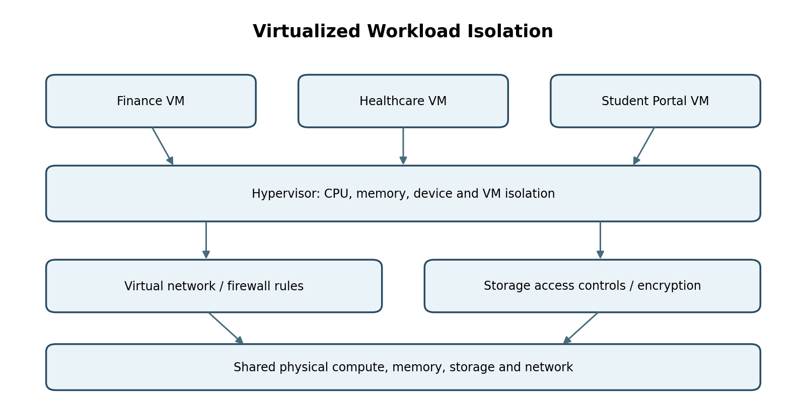

Isolation Controls
- Compute and memory: Hypervisor-enforced VM boundaries, memory protection, resource limits and patched guest operating systems.
- Network: Separate virtual networks or VLANs, deny-by-default firewall rules, micro-segmentation and restricted management-plane access.
- Storage: Separate virtual disks and access-control policies; encrypt data at rest and in transit; manage keys independently.
- Identity and monitoring: Role-based access control, multi-factor authentication (MFA), privileged-access management and centralized audit logs.

Two Major Attack Surfaces
1. Hypervisor and VM-escape vulnerabilities: A flaw in the hypervisor, virtual device emulation or management interface could allow a compromised guest to affect the host or other VMs. Reduce risk through timely patching, minimal enabled devices, hardened management interfaces and separation of administrative networks.
2. Virtual network and management plane: Misconfigured virtual switches, overly permissive security groups, exposed APIs or stolen administrator credentials can bypass intended workload boundaries. Reduce risk with least privilege, MFA, network segmentation, API authentication, configuration reviews and continuous logging.

Question 3: Analyze VM Host Utilization and Recommend Actions

Given Utilization Snapshot
Metric | Observed value | Initial interpretation
CPU utilization | 92% | Very high; limited compute headroom
Memory utilization | 88% | High; risk of reclaim, swapping or ballooning
Storage I/O latency | 35 ms | Potential storage contention; impact depends on workload and baseline
Average VM boot time | 170 seconds | Slow startup; may reflect CPU, storage, image, network or orchestration delays
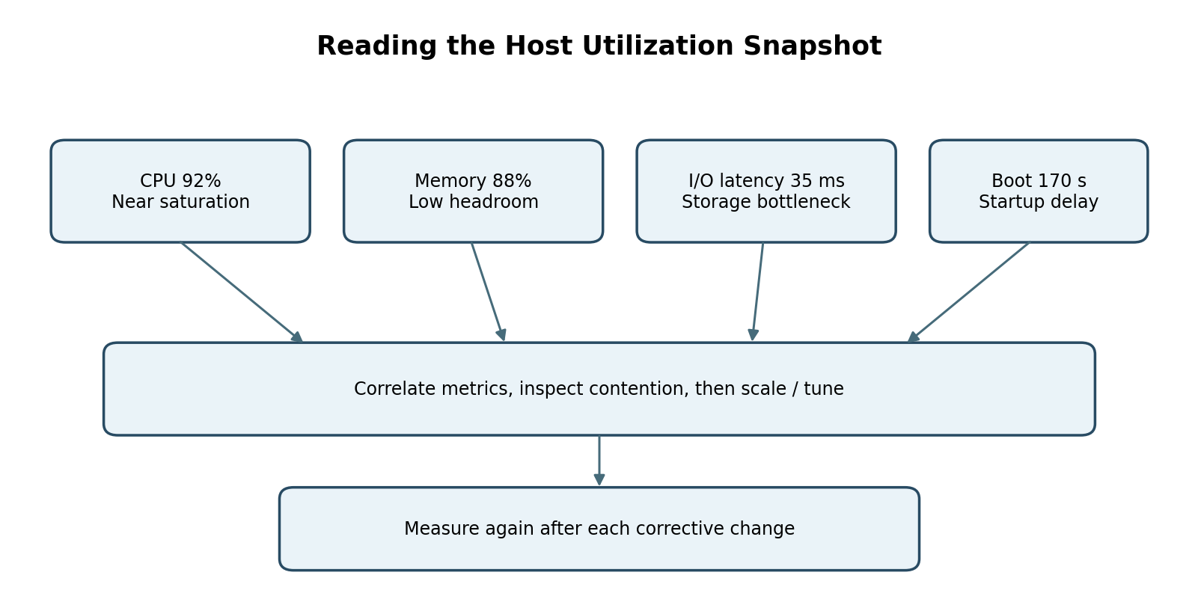

Likely Bottlenecks
CPU at 92% suggests a highly loaded host, which can increase CPU ready/wait time and delay VM startup. Memory at 88% leaves limited room for bursts; memory reclamation or swapping can add latency. Storage I/O latency of 35 ms may indicate a saturated datastore, overloaded storage array, queue depth issues or noisy-neighbor workloads. A 170-second average boot time is an outcome rather than a diagnosis; it should be decomposed into scheduling, disk read, network configuration, guest initialization and application startup time.

Corrective Actions
- Confirm the pattern over time using CPU ready/steal time, per-VM CPU usage, memory pressure, swap/balloon activity, disk IOPS, throughput, queue depth and latency percentiles.
- Right-size VMs: reduce unjustified vCPU or memory allocations, and remove idle or oversized instances.
- Scale capacity: migrate or rebalance VMs to less-loaded hosts; add compute or memory capacity if sustained demand exceeds safe operating headroom.
- Improve storage: identify hot datastores and noisy neighbors, distribute I/O, check storage paths and queues, use suitable SSD/tiered storage, and review snapshots or backup jobs that cause bursts.
- Optimize boot: use updated VM templates, avoid unnecessary startup services, investigate cloud-init/configuration scripts, use image caching where appropriate, and stagger mass boot events.
- Validate changes: compare the same metrics and workload after each change, and establish alert thresholds based on service-level objectives.

Question 4: Software-Defined Datacenter vs Traditional Datacenter

Concept and Architecture
A Software-Defined Datacenter (SDDC) abstracts compute, storage and networking into software-controlled resource pools. Policies and automation manage these pools through APIs and orchestration tools. In a traditional datacenter, many provisioning and configuration tasks are tied to separate hardware devices and manual workflows.
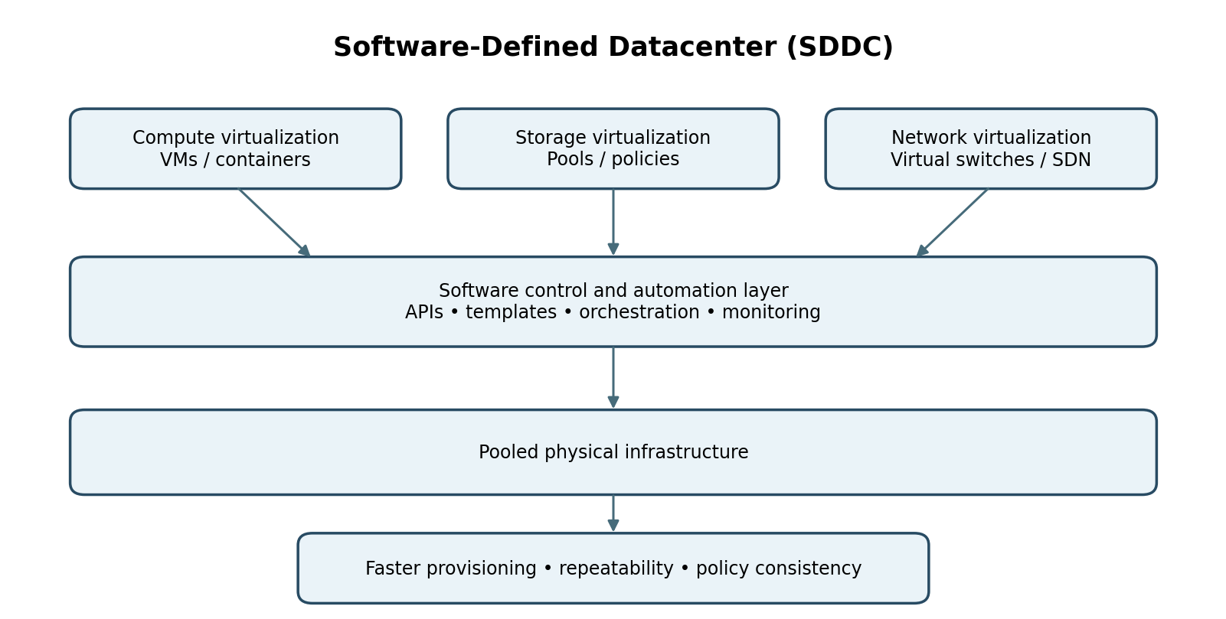

Compute Virtualization
VMs and containers let teams provision workloads from templates rather than purchase and configure a dedicated server for every service. Resource scheduling, autoscaling, live migration and infrastructure-as-code can improve utilization and shorten deployment time.

Storage Virtualization
Storage virtualization pools capacity across devices and presents logical volumes or datastores to workloads. Software-defined storage can automate provisioning, replication, snapshots, tiering and policy-based placement. Capacity, performance and resilience still depend on the underlying hardware and correct policies.

Network Virtualization
Virtual switches, overlays and software-defined networking allow networks and security policies to be created programmatically. Micro-segmentation can apply rules close to each workload, while APIs enable repeatable network setup and faster changes.

Agility Benefits and Considerations
- Faster provisioning through self-service catalogs, templates and orchestration.
- Consistency through version-controlled configurations and policy-based deployment.
- Better resource utilization by pooling capacity and moving workloads when appropriate.
- Faster scaling and recovery through automation, replication and tested runbooks.
- Trade-offs: SDDC introduces control-plane complexity, dependence on management software, automation mistakes and licensing/skills costs. Strong change control, monitoring, backups and management-plane security are essential.

Question 5: Secure Identity and Privacy in Multi-Cloud Federation

Problem Analysis
Identity mismatches occur when providers use different identity formats, user identifiers, group names, role models, authentication requirements or trust settings. For example, a group named “admin” in one provider may not mean the same privilege in another. Differences in token audience, issuer, signing keys, clock settings or attribute mapping can also cause authentication failures—or dangerous over-authorization if mappings are too broad.
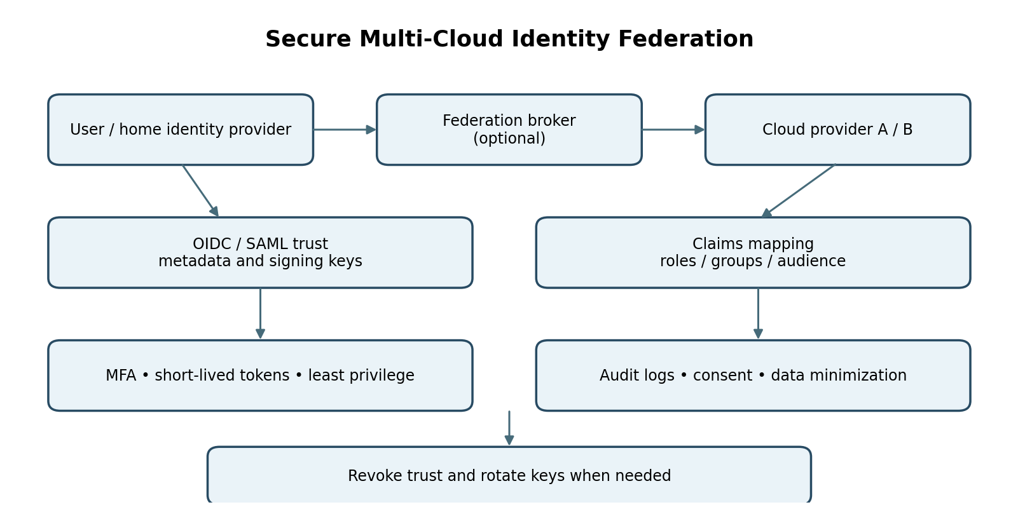

Proposed Federation Design
- Choose interoperable federation standards: use OpenID Connect (OIDC) or SAML 2.0 according to provider support. Maintain explicit trust relationships and validated issuer/audience settings.
- Establish a trusted identity source: authenticate users through a central enterprise identity provider; use a federation broker only where it simplifies provider-specific integrations.
- Normalize claims: map stable subject identifiers, groups and attributes into a documented common schema. Translate these into provider-specific roles with explicit, reviewed mappings rather than trusting raw group names.
- Apply least privilege: define roles per application and environment, use just-in-time elevation for administrators, and separate production from development access.
- Strengthen authentication and tokens: enforce MFA for sensitive actions, use short-lived signed tokens, validate issuer, audience, signature and expiry, rotate signing keys, and avoid long-lived shared credentials.
- Protect privacy: transmit only necessary claims, avoid exposing unnecessary personal data, use pseudonymous identifiers where feasible, encrypt communications, set retention limits and document consent/legal purpose where applicable.
- Monitor and recover: centralize federation and provider audit logs, alert on anomalous sign-ins and privilege changes, test account deprovisioning, and define a process to revoke trust and rotate keys quickly.

Validation Plan
Test successful login, rejected wrong-audience tokens, expired tokens, key rotation, role mapping for each user group, immediate access removal after offboarding, and access attempts between finance, healthcare and student environments. Verify that logs record security-relevant events without collecting unnecessary personal data.

